**Database homework 1 report**

**Task A:**

1. 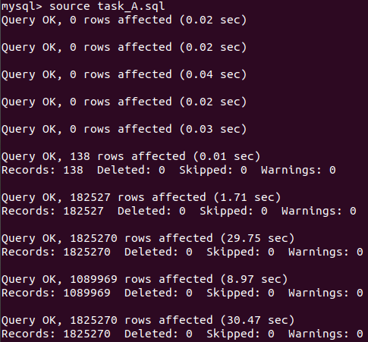Task_A.sql transcript:
2. 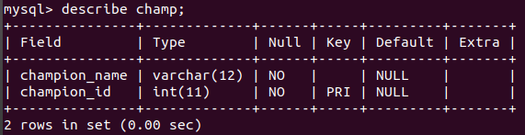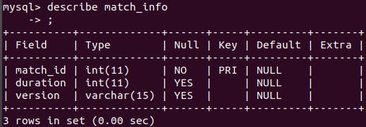‘Describe’ command for each table:
3. 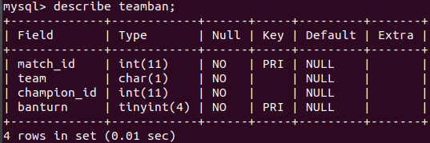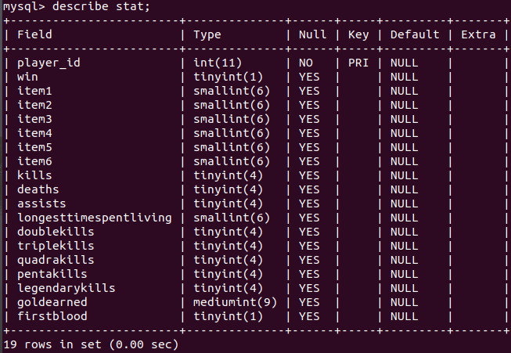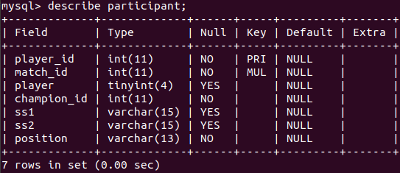Questions:
4. **What the difference between type “char” and type “varchar”?**

char: 固定大小的字符，預設大小是一，可以透過後方加上括號來指定大小。可以存比輸入預設的字符長度還小的字串，但使用的空間仍會是原本預設，會浪費空間。

varchar: 動態方式儲存自符，跟char幾乎相同，但在儲存較原本預設斥串長度還小的字串時，只會使用本身字串所需的記憶體，較省空間。

1. **Type “boolean” would be stored as which type in MySQL?**

Tinyint(1) (從stat裡的firstblood可以看到)

1. **How many bytes it should take for “tinyint”, “smallint”, “mediumint”, “int”? (e.g. 8 bytes for “bigint”) And what’s the range they can express? (e.g. from -1000 to 1000)**

|  |  |  |
| --- | --- | --- |
| Type | # of byte | Range |
| tinyint | 1 | 0~255 |
| smallint | 2 | -8,388,608~ 8,388,607 |
| mediumint | 3 | -32,768~ 32,767 |
| int | 4 | -2,147,483,648~ 2,147,483,647 |

1. **What do you think about this table schema? If you can change this table architecture, how would you modify it and why?**

**Task C:**

1. SQL Screenshot:

Query result:

1. 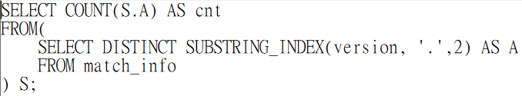SQL Screenshot:

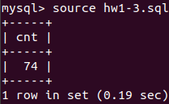Query result:

1. SQL Screenshot:

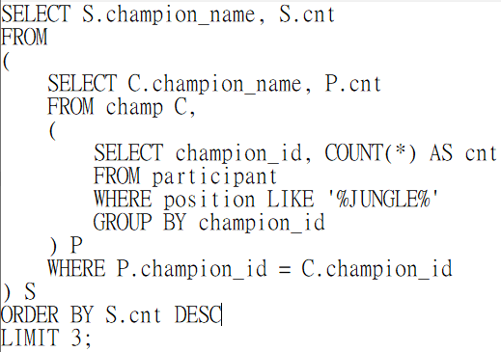

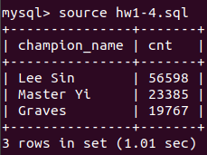Query result:

1. SQL Screenshot:

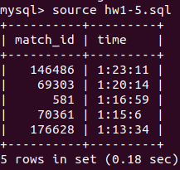Query result:

1. SQL Screenshot:

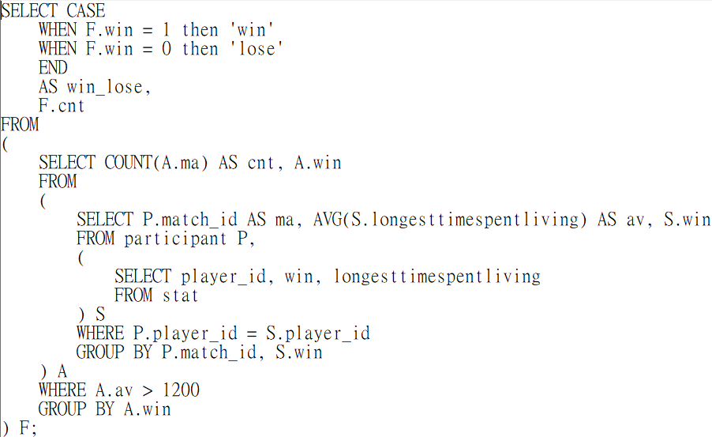

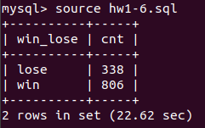Query result:

1. 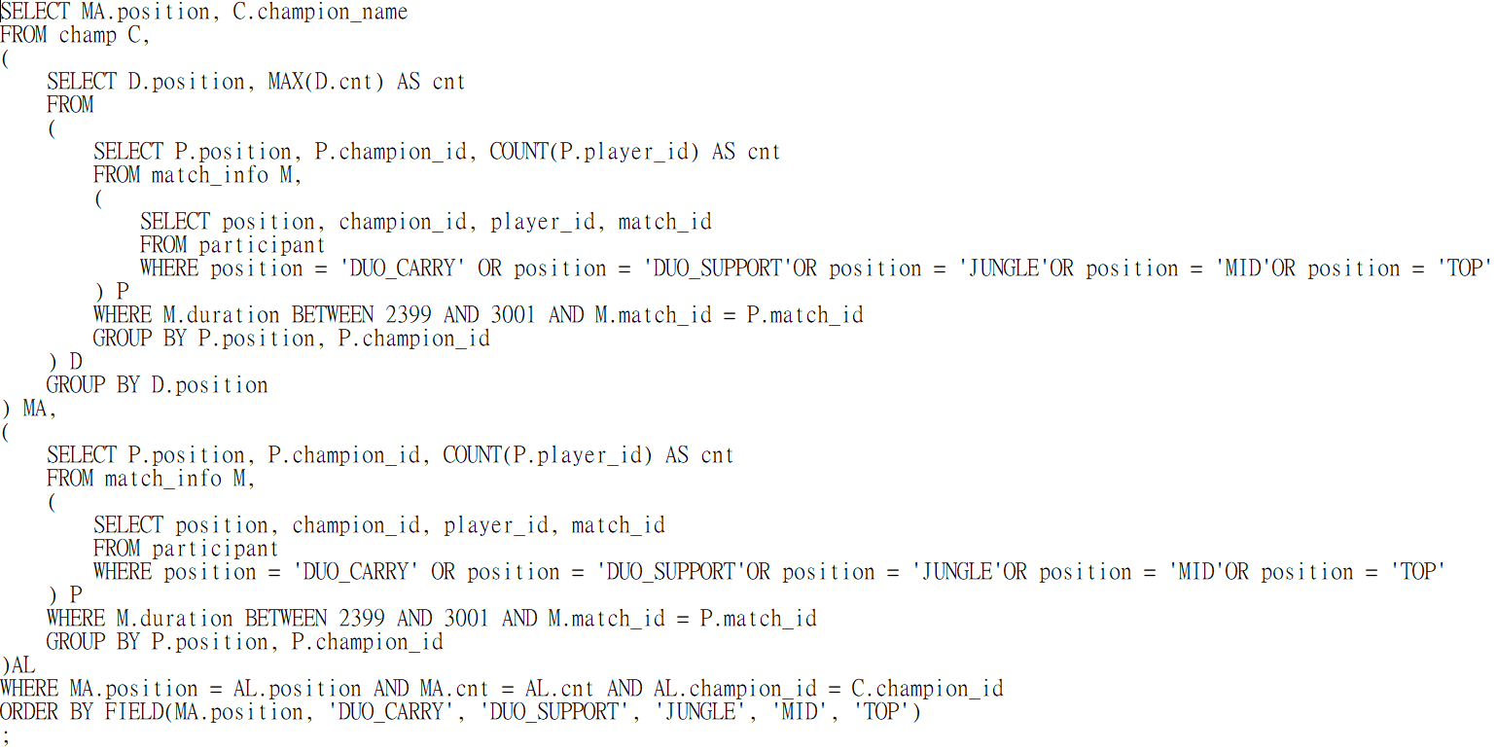SQL Screenshot:

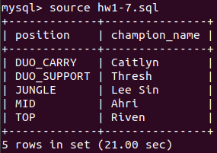Query result:

1. 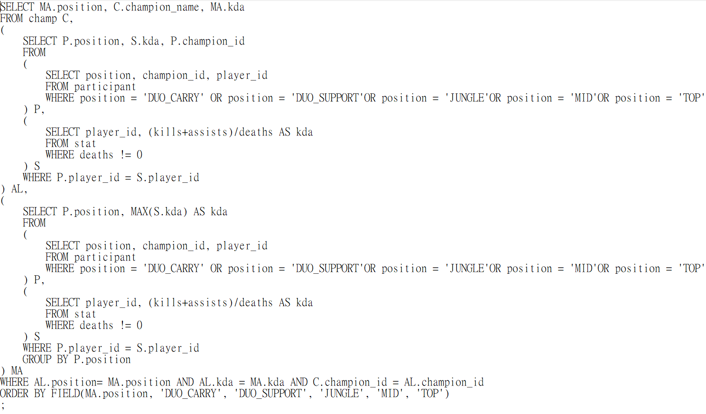SQL Screenshot:

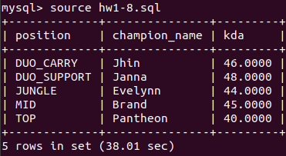Query result:

1. 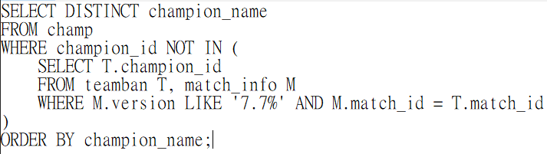SQL Screenshot:

Query result:

1. 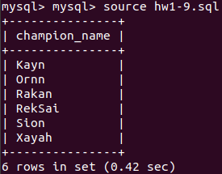SQL Screenshot:

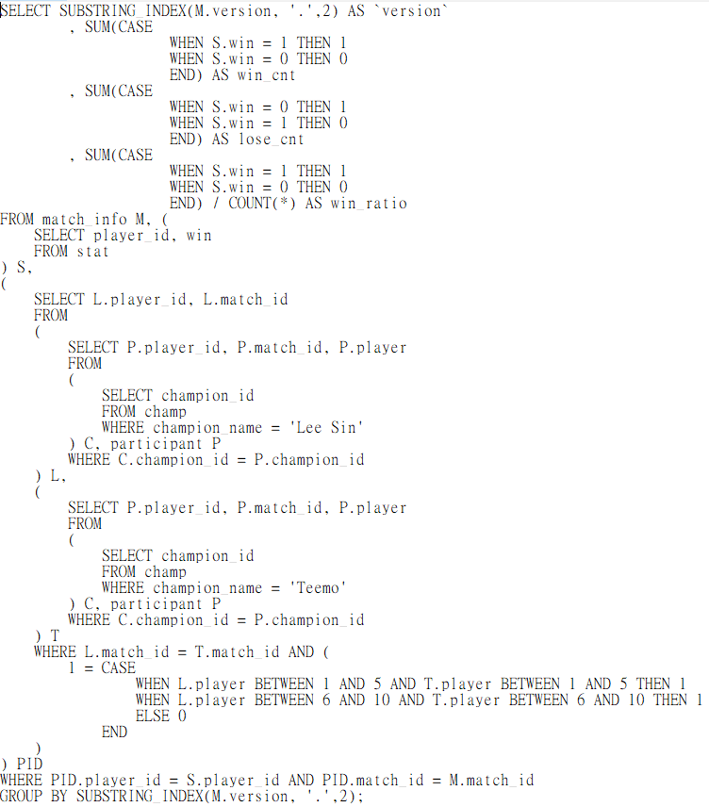Query result:

1. 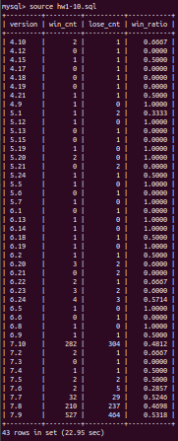SQL Screenshot:

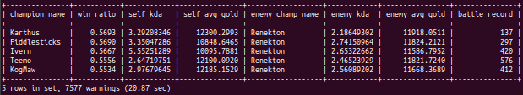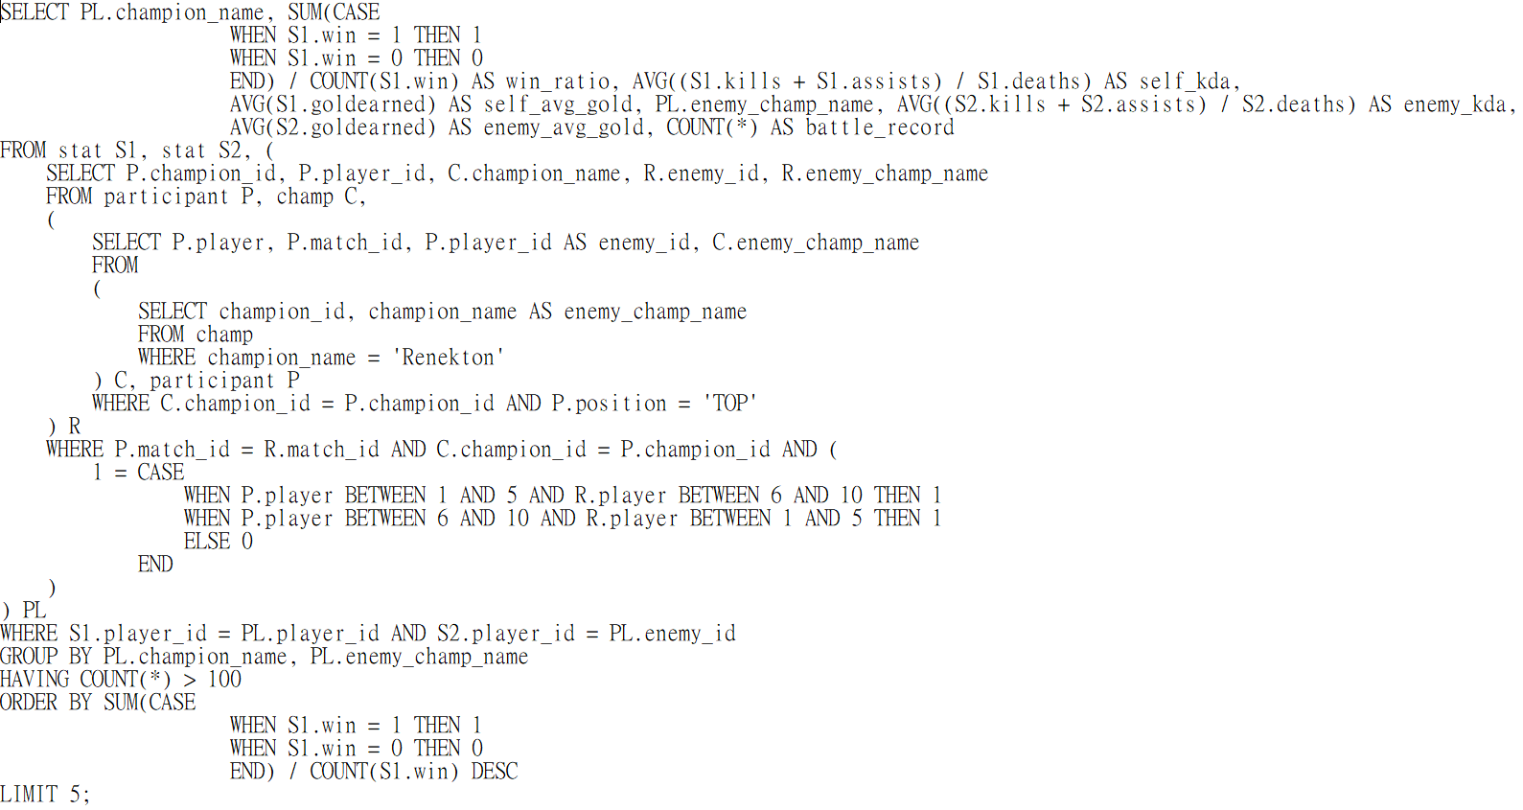Query result:

1. SQL Screenshot:

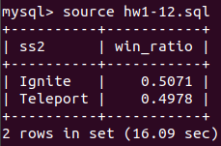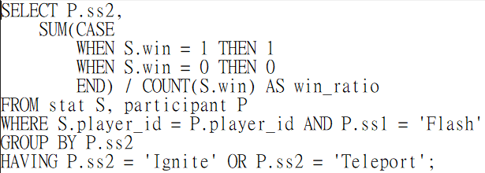Query result:

Description:

先以ss1把所有有召喚flash的participant找出來之後再進行分組，分組的方式用ss2來分，而且只有在ignite跟teleport的可以出現，計算win_ratio的方式是之前的方法，這樣就可以簡單地算出來了。